**2023학년도 2학기 [프로그래밍개론]**

**과제 보고서**

|  |  |  |  |  |  |
| --- | --- | --- | --- | --- | --- |
| 날짜 | 12월 6일 | 분반 | 03분반 | 이름 | 임다희 |
| 전공 | 컴퓨터과학전공 | 학번 | 2312282 | | |

**실행결과 화면 캡쳐**

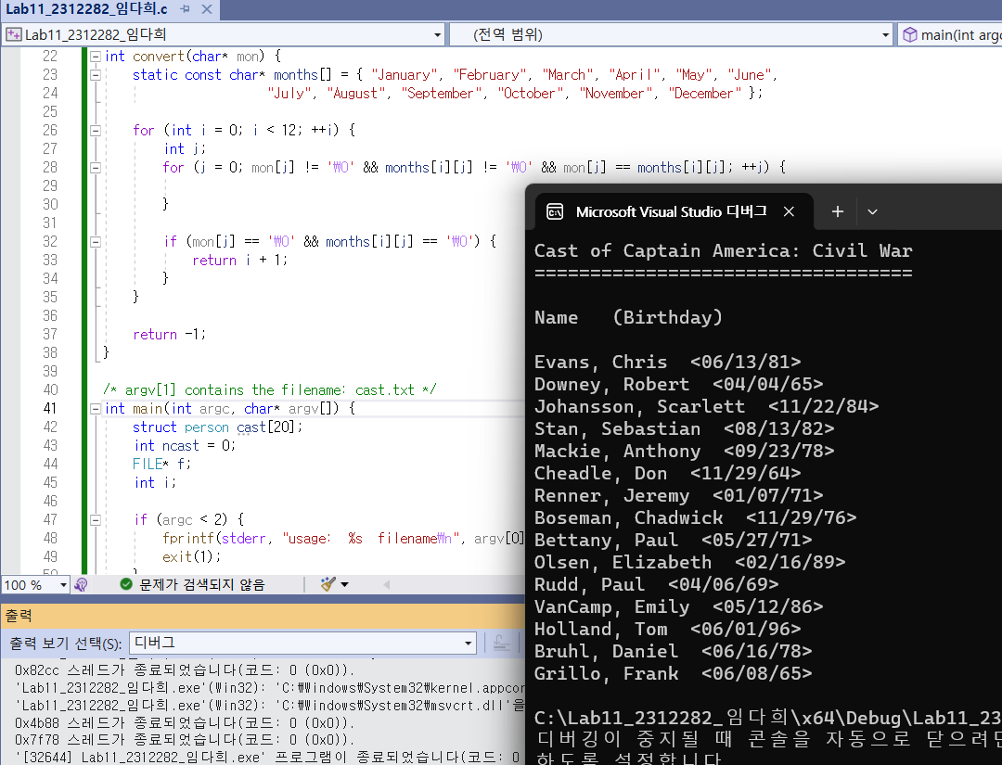

#include <stdio.h>

#include <stdlib.h>

#include <string.h>

struct names {

char first[20];

char last[20];

};

struct date {

char month[12];

int day, year;

};

struct person {

struct names name;

struct date birthday;

};

/* Converts "January", "February", ..., "December"

into corresponding numbers 1, 2, ..., 12 */

int convert(char* mon) {

static const char* months[] = { "January", "February", "March", "April", "May", "June",

"July", "August", "September", "October", "November", "December" };

for (int i = 0; i < 12; ++i) {

int j;

for (j = 0; mon[j] != '\0' && months[i][j] != '\0' && mon[j] == months[i][j]; ++j) {

}

if (mon[j] == '\0' && months[i][j] == '\0') {

return i + 1;

}

}

return -1;

}

/* argv[1] contains the filename: cast.txt */

int main(int argc, char* argv[]) {

struct person cast[20];

int ncast = 0;

FILE* f;

int i;

if (argc < 2) {

fprintf(stderr, "usage: %s filename\n", argv[0]);

exit(1);

}

if ((f = fopen(argv[1], "r")) == NULL) {

fprintf(stderr, "%s: can't open %s\n", argv[0], argv[1]);

exit(1);

}

while (fscanf(f, "%s %s %s %d, %d",

cast[ncast].name.first, cast[ncast].name.last,

cast[ncast].birthday.month, &cast[ncast].birthday.day,

&cast[ncast].birthday.year) == 5) {

ncast++;

if (ncast >= 20) {

break;

}

}

fclose(f);

printf("Cast of Captain America: Civil War\n");

printf("==================================\n\n");

printf("Name (Birthday)\n\n");

for (i = 0; i < ncast; i++)

printf("%s, %s <%02d/%02d/%02d>\n",

cast[i].name.last, cast[i].name.first,

convert(cast[i].birthday.month),

cast[i].birthday.day,

cast[i].birthday.year % 100);

}

**소스 코드에 대한 설명**